Tutorial 16

Some things to check before we move forward:
- Make sure that you referenced WIUT.DAL project from WIUT. Check previous seminar handouts for instructions. You can ensure that it’s done by examining the Dependencies section of WIUT project – you should see WIUT.DAL under Projects node:
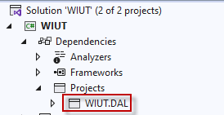

Programming exercise I – MDI Parent
- Remove default Form1
- Add new form to the project and name it ParentForm
- Set the properties of the form
  - Text => WIUT
  - IsMdiContainer => True
  - WindowState => Maximized
- Try to run the project – it will crash as Form1 was removed. Fix the code to use ParentForm as startup form of the application.
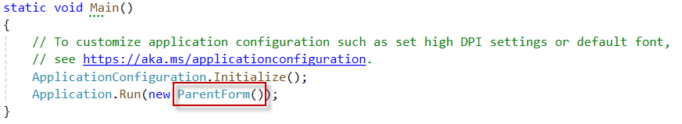
- Add menu strip and create the following menu structure
  - File
    - Exit
  - Applicants
    - New applicant
    - All applicants
  - Courses
    - New course
    - All courses
  - Help
    - About
- Add logic for File->Exit menu item
- Add new form to the project and call it AboutForm. Set
  - Text => WIUT
  - MaximizeBox => False
  - MinimizeBox => False
  - FormBorderStyle => FixedDialog
  - StartPosition => CenterScreen
- Add label with some text describing your program
- Add logic for Help->About menu item to show the form.
- Use .Show() and .ShowDialog() functions and observe the difference.

Programming exercise II – Validation
- Check all the properties of Course and Applicant class. Throw corresponding exceptions if the value passed is not valid.
- Create a temporary form in WIUT project to test validation.

Programming exercise III – Parametrized SQLs
IMPORTANT: this is the right way of doing things, but if this is too hard and/or confusing, don’t do it for your CW!
- Modify the SQL statement for Create method of CourseManager to be like that:
var sql = "INSERT INTO Course (Name) VALUES (@name)";

- Add corresponding parameter to the command:
command.Parameters.AddWithValue("name", c.Name);

- Update other methods to use parameters instead of string interpolation:

var sql = "UPDATE Course SET Name = @name WHERE Id = @id";
using var command = new SQLiteCommand(sql, connection);
command.Parameters.AddWithValue("id", c.Id);
command.Parameters.AddWithValue("name", c.Name);

var sql = "DELETE FROM Course WHERE Id = @id";
using var command = new SQLiteCommand(sql, connection);
command.Parameters.AddWithValue("id", id);

var sql = "SELECT Id, Name FROM Course WHERE Id = @id";
using var command = new SQLiteCommand(sql, connection);
command.Parameters.AddWithValue("id", id);

Home work
- Update all methods in ApplicantManager to use parameters
- Do research on Inheritance.

